U25AI055
Lab-6 Part-A
Experiment 1: Implement Stack Using Array
// Part A: 1. Implement stack using array
#include <iostream>
#define SIZE 10
using namespace std;
void push(int *stack, int *top, int x);
int pop(int *stack, int *top);
int peek(int *stack, int i);
bool isEmpty(int top);
bool isFull(int top);
int main() {
int *stack = new int[SIZE], top = -1, choice, element, position;
do {
cout << "1: Push" << endl;
cout << "2: Pop" << endl;
cout << "3: Peek" << endl;
cout << "4: Is empty" << endl;
cout << "5: Is full" << endl;
cout << "Enter choice: ";
cin >> choice;
switch (choice) {
case 1:
cout << "Enter element: ";
cin >> element;
push(stack, &top, element);
break;
case 2:
element = pop(stack, &top);
cout << "Popped element = " << element;
break;
case 3:
cout << "Enter position: ";
cin >> position;
cout << "Element = " << peek(stack, position) << endl;
break;
case 4:
if (isEmpty(top)) {
cout << "Empty" << endl;
} else {
cout << "Not empty" << endl;
}
break;
case 5:
if (isFull(top)) {
cout << "Full" << endl;
} else {
cout << "Not full" << endl;
}
break;
default:
cout << "Invalid choice" << endl;
}
} while (choice >= 1 && choice <= 5);
delete[] stack;
return 0;
}
void push(int *stack, int *top, int x) {
if (*top == SIZE - 1) {
cout << "Stack is full" << endl;
return;
}
stack[++(*top)] = x;
}
int pop(int *stack, int *top) {
if (*top == -1) {
cout << "Stack is empty" << endl;
} else {
return stack[(*top)--];
}
}
int peek(int *stack, int i) {
return stack[i];
}
bool isEmpty(int top) {
return top == -1;
}
bool isFull(int top) {
return top == SIZE - 1;
}
Output:
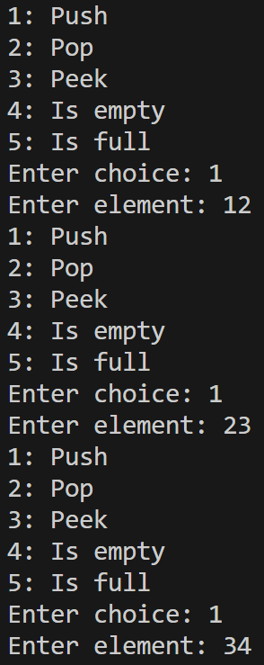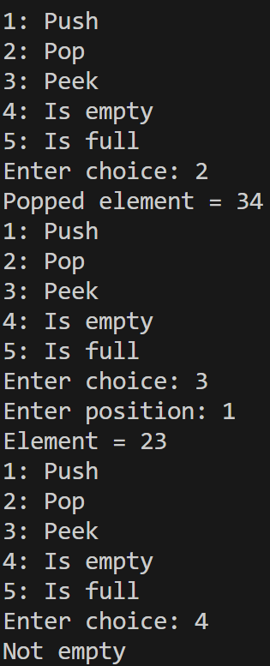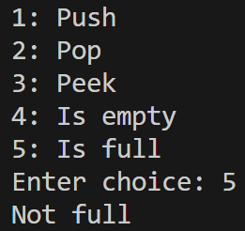
Experiment 2: Reverse a String Using Stack
// Part A: 2: Reverse a string using stack
#include <iostream>
#include <string.h>
using namespace std;
void push(char *stack, int *top, char x);
char pop(char *stack, int *top);
char peek(char *stack, int i);
bool isEmpty(int top);
bool isFull(int top);
void reverseString(char *str, int *top, char *stack);
int main() {
int top = -1;
char *stack = new char[10];
char str[30];
cout << "Enter string: ";
cin.getline(str, sizeof(str));
reverseString(str, &top, stack);
cout << str << endl;
delete[] stack;
return 0;
}
void push(char *stack, int *top, char x) {
if (*top == 9) {
cout << "Stack is full" << endl;
return;
}
stack[++(*top)] = x;
}
char pop(char *stack, int *top) {
if (*top == -1) {
cout << "Stack is empty" << endl;
} else {
return stack[(*top)--];
}
}
char peek(char *stack, int i) {
return stack[i];
}
bool isEmpty(int top) {
return top == -1;
}
bool isFull(int top) {
return top == 9;
}
void reverseString(char *str, int *top, char *stack) {
int i = 0;
while (str[i] != '\0') {
push(stack, top, str[i]);
i++;
}

for (int i = 0; i < strlen(str); i++) {
str[i] = pop(stack, top);
}
str[i] = '\0';
}
Output:
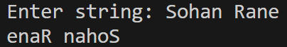
Experiment 3: Check for Balanced Parentheses
// Part A: 3: Check for balanced paranthesis
#include <iostream>
using namespace std;
struct Node {
int data;
Node *next;
};
void push(Node **head, int x);
int pop(Node **head);
bool isOpeningBracket(char chr);
bool isClosingBracket(char chr);
bool hasBalancedParanthesis(Node **head, char *expression);
int main() {
Node *head;
head = NULL;
char *expression = (char*)"[(a+b)*{c+d}]";
if (hasBalancedParanthesis(&head, expression)) {
cout << "Balanced" << endl;
} else {
cout << "Not balanced" << endl;
}
return 0;
}
void push(Node **head, int x) {
Node *newNode = new Node;
if (newNode == NULL) {
cout << "Stack is full" << endl;
return;
}
newNode->data = x;
newNode->next = *head;
*head = newNode;
}
int pop(Node **head) {
if (*head == NULL) {
cout << "Stack is empty" << endl;
} else {
Node *temp;
temp = *head;
*head = (*head)->next;
int y = temp->data;
delete temp;
return y;
}
}
bool isOpeningBracket(char chr) {
return chr == '(' || chr == '{' || chr == '[';
}
bool isClosingBracket(char chr) {
return chr == ')' || chr == '}' || chr == ']';
}
bool hasBalancedParanthesis(Node **head, char *expression) {
int i = 0;
while (expression[i] != '\0') {
if (isOpeningBracket(expression[i])) {
push(head, expression[i]);
} else if (isClosingBracket(expression[i])) {
if (*head != NULL && (*head)->data == '(' && expression[i] == ')') {
pop(head);
} else if (*head != NULL && (*head)->data == '{' && expression[i] == '}') {
pop(head);
} else if (*head != NULL && (*head)->data == '[' && expression[i] == ']') {
pop(head);
} else {
return false;
}
}
i++;
}
return *head == NULL;
}
Output:
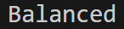
Experiment 4: Convert Infix Expression to Postfix
// Part A: 4: Convert infix expression to postfix
#include <iostream>
#include <string.h>
using namespace std;
struct Node {
int data;
Node *next;
};
void push(Node **head, int x);
int pop(Node **head);
bool isOperator(char chr);
char* convertInfixToPostfix(Node **head, char *infix);
bool hasHigherPriority(char operator1, char operator2);
int main() {
Node *head;
head = NULL;
char *infix = (char*)"(A+B)*(C-D)";
char *postfix = convertInfixToPostfix(&head, infix);
cout << postfix << endl;
return 0;
}
void push(Node **head, int x) {
Node *newNode = new Node;
if (newNode == NULL) {
cout << "Stack is full" << endl;
return;
}
newNode->data = x;
newNode->next = *head;
*head = newNode;
}
int pop(Node **head) {
if (*head == NULL) {
cout << "Stack is empty" << endl;
} else {
Node *temp;
temp = *head;
*head = (*head)->next;
int y = temp->data;
delete temp;
return y;
}
}
bool isOperator(char chr) {
return chr == '+' || chr == '-' || chr == '*' || chr == '/';
}
bool hasHigherPriority(char operator1, char operator2) {
if (operator1 == operator2) {
return false;
} else {
if (operator1 == '*' || operator1 == '/') {
return true;
} else if (operator1 == '+' || operator2 == '-') {
return false;
}
}
}
char* convertInfixToPostfix(Node **head, char *infix) {
push(head, '(');
int i = 0, loc = 0;
char *postfix = new char[strlen(infix)];
while (infix[i] != '\0') {
if (infix[i] == '(') {
push(head, infix[i]);
} else if (infix[i] == ')') {
while ((*head)->data != '(') {
postfix[loc++] = (*head)->data;
pop(head);
}
pop(head);
} else if (isOperator(infix[i])) {
if (isOperator((*head)->data)) {
if (hasHigherPriority(infix[i], (*head)->data)) {
push(head, infix[i]);
} else {
while (isOperator((*head)->data) && hasHigherPriority((*head)->data, infix[i])) {
postfix[loc++] = (*head)->data;
pop(head);
}
push(head, infix[i]);
}
} else {
push(head, infix[i]);
}
} else {
postfix[loc++] = infix[i];
}
i++;
}
while ((*head)->data != '(') {
postfix[loc++] = (*head)->data;
pop(head);
}
postfix[loc] = '\0';
return postfix;
}
Output:
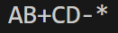
Experiment 5: Evaluate a Postfix Expression
// Part A: 5: Evaluate a postfix expression
#include <iostream>
#include <string.h>
using namespace std;
struct Node {
int data;
Node *next;
};
void push(Node **head, int x);
int pop(Node **head);
bool isOperator(char chr);
int evaluatePostFix(Node **head, char *postfix);
int main() {
Node *head;
head = NULL;
char *postfix = (char*)"82/3-";
int result = evaluatePostFix(&head, postfix);
cout << result << endl;
return 0;
}
void push(Node **head, int x) {
Node *newNode = new Node;
if (newNode == NULL) {
cout << "Stack is full" << endl;
return;
}
newNode->data = x;
newNode->next = *head;
*head = newNode;
}
int pop(Node **head) {
if (*head == NULL) {
cout << "Stack is empty" << endl;
} else {
Node *temp;
temp = *head;
*head = (*head)->next;
int y = temp->data;
delete temp;
return y;
}
}
bool isOperator(char chr) {
return chr == '+' || chr == '-' || chr == '*' || chr == '/';
}
int evaluatePostFix(Node **head, char *postfix) {
int i = 0, result;
while (postfix[i] != '\0') {
if (isOperator(postfix[i])) {
int a = pop(head);
int b = pop(head);
switch (postfix[i]) {
case '+':
result = b + a;
break;
case '-':
result = b - a;
break;
case '*':
result = b * a;
break;
case '/':
result = b / a;
break;
}
push(head, result);
} else {
push(head, postfix[i] - 48);
}
i++;
}
return (*head)->data;
}
Output:
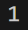
Experiment 6: Design a Stack with Minimum Element Retrieval
// Part A: 6: Design stack with minimum element retrieval
#include <iostream>
using namespace std;
struct Node {
int data;
Node *next;
Node *minimumBelow;
};
void push(Node **head, int x);
int pop(Node **head);
int findMinimum(Node *head);
int main() {
Node *head = NULL;
push(&head, 6);
push(&head, 2);
push(&head, 9);
cout << "Minimum = " << findMinimum(head) << endl;
return 0;
}
void push(Node **head, int x) {
Node *newNode;
newNode = new Node;
if (newNode == NULL) {
cout << "Stack is full" << endl;
return;
}
newNode->data = x;
newNode->next = *head;
if (*head == NULL) {
newNode->minimumBelow = newNode;
} else {
if (newNode->data < (*head)->minimumBelow->data) {
newNode->minimumBelow = newNode;
} else {
newNode->minimumBelow = (*head)->minimumBelow;
}
}
*head = newNode;
}
int pop(Node **head) {
if (*head == NULL) {
cout << "Stack is empty" << endl;
} else {
Node *temp = *head;
*head = (*head)->next;
int y = temp->data;
delete temp;
return y;
}
}
int findMinimum(Node *head) {
return head->minimumBelow->data;
}
Output:
